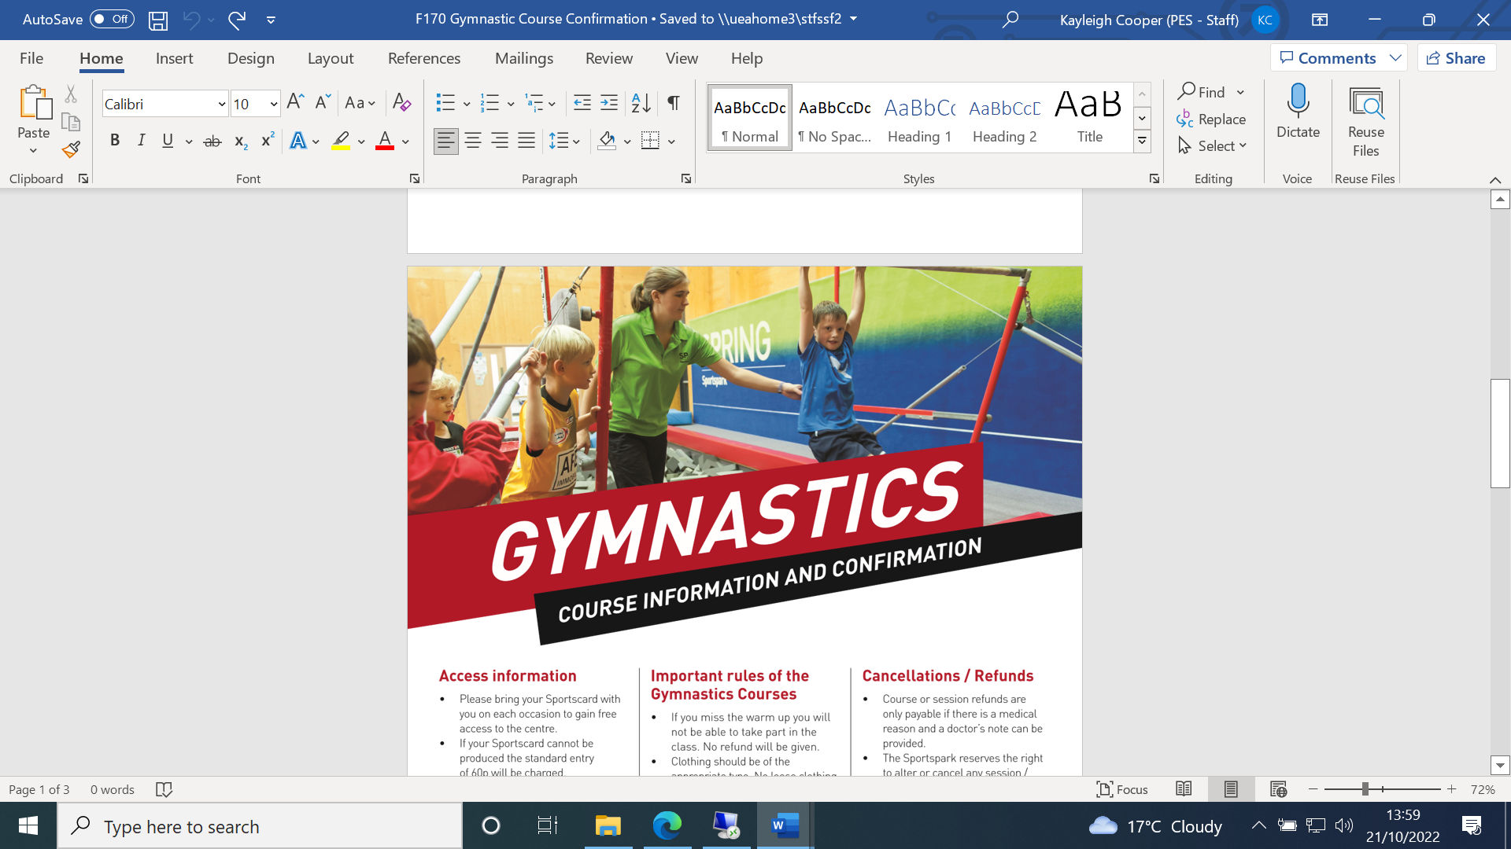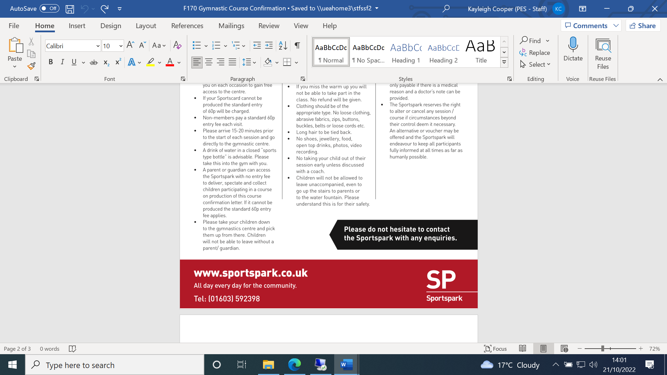

***SAFEGUARDING***

* Under no circumstances should children under the age of 12 be left unaccompanied at the Spring Gymnastics Centre.
* Coaches will take responsibility for children during their gymnastics lessons however parents/guardians are requested to remain in the building to deal with toilet breaks or behavioural issues if required. For children under 12 years old a parent/guardian MUST remain in the building at all times.
* Child to coach ratios are developed in line with relevant governing body guidelines.
* All coaches are qualified with the necessary qualifications relevant to the course and will have current DBS checks in place.
* When getting changed for lessons, children 8 years old and over must use the changing room specific for their gender.
* Please make sure you are ready to collect your child/children promptly at the end of their lessons.
* No photographic equipment or any other form of visual or sound recording equipment may be used at any venue without the prior consent of Sportspark management.